American & Railway Express company property marks
From: Wells Fargo Schofield - Authentication (smith-wessonforum.com)
One more comment on "EXPRESS" guns? It's documented that the vast majority (not all but most) were ordered by EXPRESS companies like American, US, Railway, etc......very late in the 1890's to early 1900's. Factory marked examples and orders of over 1200-1500 38 cal topbreaks as an example were not uncommon for various EXPRESS companies. I have several topbreak 38 cal Smith & Wessons of various models that letter as EXPRESS guns and are so marked. My point being that they were ordered late in the 1800's and very large orders placed! This doesn't include large orders of Colt lightnings and Iver Johnsons that are confirmed. 800-1200 units in the separate orders placed. This data just proves that "many" were ordered and are authentic via research confirmation and Factory documents. Add them up and you come up with literally thousands of "Factory Ordered" EXPRESS GUNS! That doesn't include guns ordered directly from Distributors!
B. Murph

Ed puts forth a good point of conjecture being there were more than one Wells Fargo armorer and more than one locations. Likely more than one stamp.
Personally, I don;t like the floating W or F. I like the entire phrase to be on one line stamp, in line, even if stamped at a slight angle. The SN restamped on the side ahead of the WF & cos stamp all seem to be the same or very similar but not identical, again, on one line.
I learn something new every day it seems. Adding more to my data base. Also finding many more sources of information that seem promising.
Especially on the "EXPRESS" guns from factory ledgers (factory letter) research. I believe that the documented information contained in the Colt and Smith & Wesson archives regarding shipping information, factory markings, persons of interest, who received the guns, who ordered the guns, how many were shipped, a definite pattern of ordering, and where they ended up is critical
We can most definitely cross reference very distinct patterns followed by American Express and Wells Fargo Agents when ordering guns from the factory after 1892. Before this time the vast majority were ordered directly from the Major Distributor.
Even Mr. Jinks clearly mentions that in several factory letters that I have read on Smith & Wesson 38's ordered in the early 1890's from the factory by Agents representing the Express Companies.
The more information I confirm from factory letters the more odd' the Schofields are. They actually make little sense from a timeline perspective. I've extended the late W.F. & CO. EX. barrel stamp to serial number 3500 in the model 1. Also, if you follow the methods used by Company Purchasers/Agents?
They consistently ordered specific amounts of guns "Monthly" that "NEVER" exceeded 50 guns per order over a 25 year documented period!!!! So a bulk order of Schofields of over 50 guns per order at any time is "extremely unlikely". This information follows a long term "fill as needed" pattern to "ALL" Express guns from the late 1880's until about 1917.

A very distinct pattern is developing in my data that supports a very steady "HUGE" order of EXPRESS guns over very long periods of time. In some cases 1700 guns and 1900 guns over a 20 year period. That only accounts for a small percentage! It's documented!

Murph
I’ve found a ton more information on Wells Fargo Express Co. Also many other Express companies that purchased Cartridge revolvers from the Late 1870’s up to the 1930’s.
When we look at the origin of Wells Fargo Express Co. It began in San Francisco in 1852 as “ Wells Fargo & Co.” not CO’s.
I’ve found dozens of period photos that clearly show Wells Fargo and Company Express on office signs, Stage coaches, strong boxes, letters, checks, shot guns, leather satchels, money orders, bank receipts, and most importantly early Distributor purchased Colt Lightning’s that date to the late 1870’s and early 1880’s. Even one as late as 1892 having a very small stamp like is seen on the Schofield barrel. The stamp depicts : WELLS FARGO & CO. NOT CO’s!
So basically I’m finding only strong evidence that these Wells Fargo Surplus Schofields were purchased by Agents representing Wells Fargo & Co. Express Primarily “ Prior” to 1890!
I’ve even found Colts that are backed by Factory Letters having a factory stamped: W.F.& Co. ( Not CO’s) on the backstrap initially, then post 1895 on the butt.
I’ve always believed these were early Cartridge guns for Wells Fargo. Post 1898 makes Zero sense for the Surplus Schofields.
Murph
So basically All the information that I've found backs up the Historical Department from Smith and Wesson and the 60 plus years that they have been at it.
So, one final input on the Co's vs Co on the Wells Fargo Schofield stamp? Prior to 1898 when the Company implemented a Streamline "Wells Fargo & Company Express"....there was no set company Standard...It was ALL over the place based on what part of the country and what office you happened to be referring to. Thousands of them after 1870!
So the product line was basically terminated in 1878. When Wells Fargo purchased the Surplus Schofields in bulk they were still relatively new.
However, when we follow an accurate timeline using the Major Distributors as a guide we see the Schofields becoming quickly obsolete approximately 10 years later. This is the Standard for any firearm manufactured throughout history that has been discontinued. Parts become scarce to none available approximately 10 years after termination of the product line.
This also supports that the bulk of the Schofields were purchased early in the 1880's by not only Wells Fargo but American Express as well. I found a lot of evidence that they also purchased Surplus Schofields.
So basically the information and data collected supports that Wells Fargo & Co Express and also American Express Co. basically unloaded the bulk of the Schofields prior to 1890 as no longer serviceable revolvers and replaced them in a very short period of time with .38 caliber revolvers of various makes and models. Also clearly documented by 1890 with consistent and detailed factory letters that I have collected.
These letters also depict a very clear and distinct pattern used by agents representing the Express Companies that streamlined purchases from initially the Major Distributors and finally directly from the gun manufacturers in the early to mid 1890’s. All proven from factory recorded data.
Murph

The subject of Company stamps is in no way a small one. I'm trying to consolidate the subject but it's difficult.
Lets begin by recognizing the correct term that has been given to the various Express Stamps from the Historical Department and Mr. Jinks.
In several letters that I have read Mr. Jinks calls the stamps "PROPERTY STAMPS" and the numbers "PROPERTY NUMBERS" so I'd like to follow that lead.
Wells Fargo and American Express both purchased the Schofields. I've also cross referenced the early 38 Colt lightning Property stamps from both companies...See photo 1 and 2...Notice also the Wells Fargo & Co stamp on the backstrap....NOT Co's! The 38 Colt lightning in photo 1 is lettered from the Railway Express Agency( successor to Wells Fargo & Co Express) that confirms it was a Wells Fargo owned Express gun. It also has a Colt factory letter that proves it was shipped through the correct and known Chicago agency "Hibbard, Spencer & Bartlett" in 1878! They were a "HUGE" Express agency gun relay point in history. Documented in several factory letters! The 38 Colt lightning is also an excellent reference gun since it is documented from the advent of production in 1877 to the end in 1909 as being an Express gun for several outfits!
The earliest Property Stamps were stamped by the relevant Express Agency. Photo's 1&2. With NO property number stamp. Just the Express Company Property stamp. Those date to the late 1870's to very early 1880's. I've done no research before cartridge firearms. Only because the records are basically non existent. Not much to go on.
After about 1880 they began stamping a property number next to the property stamp. Also in small letters and numbers "Hand stamped".
So based on that information alone the earliest Schofields that have Wells Fargo property stamps and small property numbers are the earliest guns. Likely from late 1880-1882. See photo 3. These property numbers as you know match the serial number.
The next sequence I documented is the medium size Property number. Unfortunately, I have not been able to cross reference date that variation. I've seen and documented medium sized property numbers from the mid 1880's (based on serial number dating) on the colt lightning backstraps but I have no factory historical reference on those as yet.
It's possible that what we are seeing on the Schofields is just a different office from another location that used a larger stamp at the same or around the same time. The early to mid 1880's.
I've found also that the Property name Wells Fargo & Co's Express was more often used in the Mid-West States...You can find it most anywhere but per capita? The Mid-West predominantly used that Company title with the Co's. The far West used Co. So most of the earliest Schofields likely went to the front lines in California, Nevada, etc. Where all the Express robberies were taking place. Makes perfect sense!
So the large Property number would also fall in the same timeframe. Likely the latest Property number stamp but we are only talking a few years. All taking place way before 1890 and at various locations, stations, etc throughout the WEST...
Remember again that the vast majority of the robberies and unlawful activity is documented as taking place in "The Wild West"....So West of the Santa Fe trail after being shipped through the Chicago office...This represents the "Bulk" of the guns...Not all but the Bulk of them. There are always exceptions.
I've found some Express guns that were shipped directly to San Francisco via Colt factory letter. All consistently stamped with the Property Stamp: WELLS FARGO & Co. EXPRESS or just Wells Fargo & Co, in some instances just W.F. & Co. in small to medium sized letters. With all these guns shipped in the 1880's. This is just further Rock Solid proof that you can't date the Schofields by Co vs Co's.

All of the Company Property Stamps and Property number research is very consistent and well documented beginning in the early 1890's. I'll post that next and you will "Clearly" see the pattern that is undeniable and has absolutely nothing in common with the Early Schofield Wells Fargo guns of the 1880's.

Murph
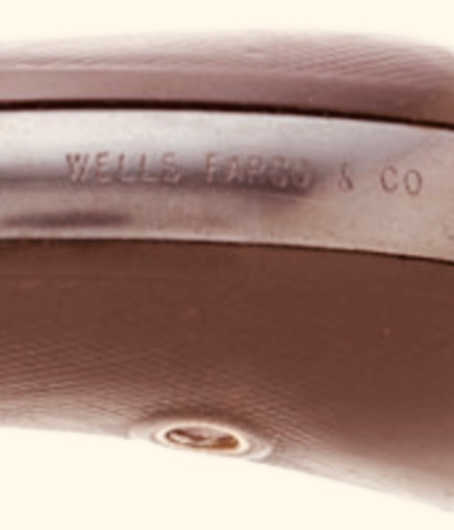
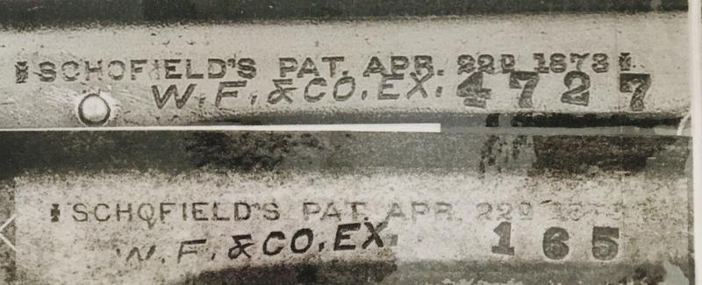
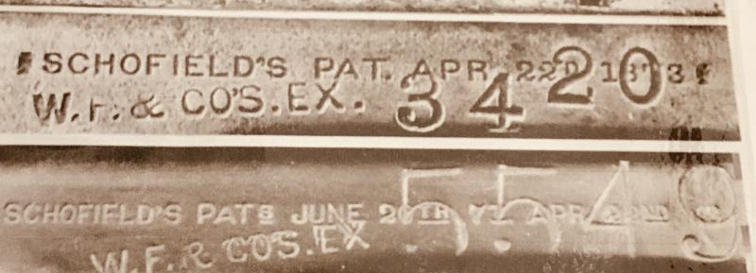
Lets begin again with the Smith & Wesson Historical Department where Mr. Jinks states: "Hartley & Graham purchased large quantities of the 38 cal Top break revolvers and supplied American Express Co in the early 1890's prior to the Express Company ordering them directly from the factory".
My research supports that these large quantities of 38 caliber top break Smith & Wesson revolvers "REPLACED" the now aged and obsolete Schofield Revolvers of the 1880's.
This also gives us an idea of how many Schofields were in the field for Wells Fargo and American Express Co. The initial volume of new 38's suggests well over a thousand at least.
See photo 1 where initially the Agents representing the Express Company's purchased very large quantities of 38's and had the Major Distributor Engrave the backstrap with Their Property Name and Property number. This marks the end of Wells Fargo and American Express stamping the guns. US Express and Pacific Express would continue stamping their guns into the mid 1890's. However, those stamps would also be much larger in font. "HUGE" in some cases!
This represents the beginning of the modern streamline purchasing process. Initially purchasing from the Distributor, having them mark the guns. Then a change to Purchasing directly from the factory and having the factory stamp/engrave the guns in the early 1890's. This process is followed by my research until the 1930's. At no time did the Express Company's go back to stamping their guns once they started purchasing large volumes of new guns from the Major Distributor beginning in approximately 1887.
So again, once this procedure started, there is no evidence that they ever went back. Photo two shows a "Factory" marked Smith and Wesson 38 topbreak. This contract lasted from 1892-1905 totaling approximately 1700 guns in 38 caliber.
The Wells Fargo Express guns now show a very distinct stamp on initially the backstrap and eventually moved to the butt: W.F.& Co. Notice also the elimination of Express in the property name?
American Express guns were stamped Am. EX. Co. followed by a property number until approximately 1909.
So we can clearly see that the Schofields had no place in the 1890's. They were not only obsolete weapons but the stamps do not in any way resemble the 1890's Property and Property number stamps. Had they made it to the 1890's? The property and property number stamps would have changed!! They would have been moved to the back strap and/or butt. Without question! Just like the Colt lightning Property stamp changed over the years of service in the Express division. From small letters to medium letters and numbers. Then large cursive letters and numbers. We saw none of this occurring with the Early Schofields! The property stamps remained very small and the property numbers remained individually "hand stamped". They never saw Distributors stamping the guns in a clean, engraved, large cursive manor! Lets also input the Express Company's obvious preference in ordering the 38 caliber small framed weapons by a "HUGE" margin.
There were some 44 WCF DA Colt Frontiers that letter and 45 Colt SAA that also letter but they represented a very small number. Huge volumes by Huge I mean "MANY THOUSANDS" of 38 caliber revolvers over the next 40 years covered in my research were purchased.
My last input on the Express guns will be on "Records"
Murph
Other factory letters and recorded data confirm a person of interest by the name of C.E. Seaton. He was a purchasing agent for American Express Co from the late 1880's until my last recorded data about 1909. This specific 38 Smith & Wesson topbreak contract beginning in about 1892 and ending in 1905 with very close to 1700 guns shipped from the factory....Yours would be one of the last shipped in that contract.
Anyway, the shipping address is often not listed in the factory ledger. Often the buyers address in Springfield is listed as the shipping address. That is actually the location of the American Express office. Which is correct but my research proves that they were actually authorized to be shipped to WM Read & Sons of Boston, Mass by the Agent representing the Express company. They were a significant Distributor of American Express guns. From there many but not all would be shipped to Chicago as a "HUGE" relay point for Express guns moving further West to supply Agents in "The Wild West".
All of this is documented. I also confirmed an "Identical" contract of 38 cal "Colt Lightnings" under the exact same conditions. Data proves the purchaser was the agent C.E. Seaton representing American Express Co. He is also listed as a buyer and head of Supply Department.
However, the exact same source claims that he was only the buyer. He might have changed titles throughout his tenure. He authorized the guns to be Shipped to the exact same distributor in Boston. W.M. Read & Sons and in turn using them to ship at least some of the large order of 38's to Chicago for Distribution. This was the process used in the 1890's. A very modernized and efficient method of moving guns safely and securely about the country. They used a similar process in the 1870's and 1880's but it was in no way as efficient. Too much info to post.
That same large contract of Lightnings almost mimics the Smith & Wesson 38 top break contract. Beginning in 1892 and ended with the termination of the lighting model manufacture in 1909. Almost 2000 guns were in that contract.
I actually have a ton more information on other contracts that amount to many thousands of guns but its too lengthy....I'm putting folks to sleep I'm sure but this information is very important to evaluating the Schofields. It proves "Methods Used" in that timeframe. Those Methods are very important to evaluating what was going on at that time in the industry. It clears the air when no records are available for the subject of interest and paints a very readable picture of how Agents representing the Express Company's operated.
When we plug the Schofields into these early 1890's contracts they simply don't fit. They only fit like a glove in the early 1880's. I don't claim to be any sort of an expert. I'm only a student that "Does his Homework".
Murph
I have enough information now to input Part 1 of "Records".
A quick History of the End of Wells Fargo & Co. Express occurred in 1918 by order of the President of the United States. Woodrow Wilson ordered that the Private sector of the Express business, that primarily by that time involved the Railroad to ship goods Express, to be consolidated for the good of the country during time of war.
The result was the total elimination of the Private sector and the consolidation of all Express Companies into a Public Express Company controlled by the Government. This included the immediate elimination of the following private Express Companies;

Adams & Co.
American Express Co.
Southern Express Co.
Wells Fargo & Co. Express

This marked the end of those companies involvement in the Express business and the creation of:
The American Railway Express Company.( Government controlled) check out extremely rare photo WWI Era of The American Railway Express with WWI Military in uniform next to Railway office!
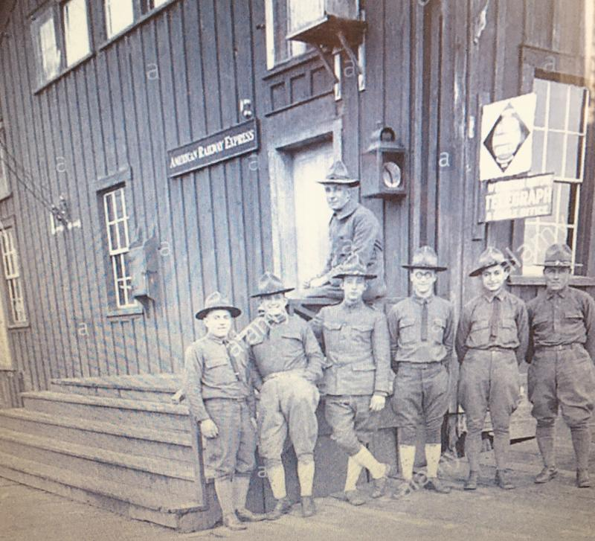

It is documented that those companies that were basically dissolved by the U.S. Government were required to "turn over property and guns" to the newly created Public Express Company.
This is documented.
After the war an association of Railroads was created and eventually bought out American Railway Express Co. in 1929 and formed the new Company: Railway Express Agency.(REA)
This company lasted until 1975 at which point they went bankrupt for various reasons.
Now to the records....What apparently happened is in 1918 the guns that were surrendered by the various Express companies were recorded by the Government controlled American Railway Express Co. They were inventoried and recorded. Those were NOT Wells Fargo Records! I found no evidence that Wells Fargo turned over their records.
New records were established in 1918 that simply recorded which company surrendered what guns, specific model, and serial number.
For many years The REA would letter guns for collectors up until about 1969 was the latest letter I could find. See photo 1.
When REA went bankrupt their records went to the Smithsonian. Those records in part are available. I looked through them. I also contacted an archivist and found that the firearms records were destroyed. Not surprising since they went bankrupt right at the end of the Vietnam war. Not much interest in firearms after that War by the various "Left".
I'm applying my researched opinion at this point. I don't believe those records would have helped us anyway. All of my research points at the Schofields no longer being viable revolvers after 1890. So in my researched opinion the "Bulk" of them were sold as once again, Surplus weapons, to the general public,etc. So when the guns were turned over in 1918, none of them were Schofields so no records were generated.
What also backs this position up is that I could find NO authentication letters from REA on Schofields. "If" they exist they would be extremely rare. If anyone has one? I'd like to see it but I honestly believe they do not exist.
So, what's left? I have my feelers out still with the Senior Historian with Wells Fargo and one other.. Waiting for their response.
Murph
I received an email that I wanted to share with the forum.
A question was brought up regarding REA authentication letters.
Question: How did REA have records on an 1878 Colt lightning Wells Fargo Express gun that you mentioned in one of your posts but not have information on the 1880's Schofields?
The Colt lightning revolver differs from the Schofield in that it was manufactured until 1909. The Schofield product line was terminated in 1878.
This actually follows my evaluation of the research data. The Schofield was obsolete primarily due to NO parts being available after about 1890.
Where as the Colt lightning remained a viable Field revolver due to factory original internal "PARTS" still being manufactured likely until about 1919....So at least some Colt lightnings definitely were surrendered to the American Railway Express Co in 1918.
Had the Schofield been manufactured beyond 1900? The results would have been much different and records would most definitely be available from several sources including the Smith & Wesson factory I'm sure! I honestly don't know why the Schofield line was terminated so early. There was definitely public interest in the shorter barrel version. Makes little sense to me personally. I think it would have sold to the public and would have been a viable competitor to the Colt SAA. It probably had something to do with the royalty going to Schofield per gun sold?
Murph

Last edited by BMur; 03-16-2020 at 06:12 PM.

I firmly believe based on the information found that there were a lot more Schofield Surplus revolvers purchased by both Wells Fargo and American Express than we might have believed.
If we look at the multiple contracts from the early 1890's to early 1900's we can verify over 5000 revolvers purchased by American Express alone!
So I firmly believe that at least a couple thousand Schofields were purchased split between Wells Fargo and American Express Co in the early 1880's. They followed the same pattern of purchasing for decades! Same exact guns!
Also, if we have an open mind and consider that when these Wells Fargo Schofields went to Surplus from the Express Agencys? Many of the Property markings were removed. I documented several in my survey. It makes perfect sense. Whether removed prior to sale by the Express company or by the Civilian buyer who didn't want that property stamp on "their" firearm to avoid accusation of theft!
Then we plug in a collector 140 years later who can't help but attempt to re-apply the property stamp to increase the value of their antique revolver? You have yourself a huge mess of guns that were likely Express Guns originally but have seen the file and die stamp more than once.
